LAKE PEWAUKEE SANITARY DISTRICT 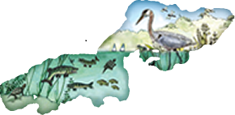 JANUARY, 2021 LET’S PUT 2020 BEHIND US AND HAVE A PROSPEROUS AND HEALTHY NEW YEAR!

NEW – ACH Payment Program – Lake Pewaukee Sanitary District is offering this payment option as a convenience. If you would like to participate & pay your quarterly sewer bill through an ACH withdrawal, please fill out the enclosed form & return with an attached voided check. Funds will be withdrawn on the 20th following your quarterly billing. (January 1st, April 1st, July 1st & Oct. 1st) If you have any questions please feel free to contact our office at (262)691-4485.

SEWER SYSTEM
USER FEE SLOWLY RISES WITH THE COST OF LIVING
The new rate for our quarterly sewer user fee will be $121.00 starting with the April 1st, 2021 billing. The user fee covers the operations and maintenance of the sewer. These costs to the district continue to rise and it is not in our control - the price of parts, pumps, transfer switches and generators simply continue to rise as well as construction costs. Several pumps have been replaced as well as some internal piping inside the wet wells that have corroded over the past 35 years. A few stations have been upgraded and several more stations need to be done over the next few years. Generators are in need of replacement, mostly due to not being able to find parts for the older ones that aren’t made anymore. The generator housing units that were made of fiberglass are deteriorating and in need of replacement. Several have pumping stations have been done, some are being completed this year and a few need to be done over the next few years.
Remember - Don’t throw rags or cleaning “flushable” wipe’s into the toilet, it clogs pumps and cause costly “extra” maintenance that we all pay for. Help keep our rates down, don’t flush anything except toilet paper!!

LAKE CLEAN UP SUMMARY
It was once again a fair year with the aquatic plants on the lake. Clean-up crews worked through October cutting, picking up shorelines and doing lots of pile pick up. Below is a chart that shows the volume of aquatic plants taken out of the lake over the years and how this last year compares to the previous years and cycles.
The total volume of aquatic plants removed from the lake equates to 6,189 cubic yards. Below is a graph of the volumes of aquatic plant removed over the past 30+ years. The tallest spikes are the combined volumes of all the methods of the districts aquatic removal operations (the harvesters, shore barges and pile pick up).
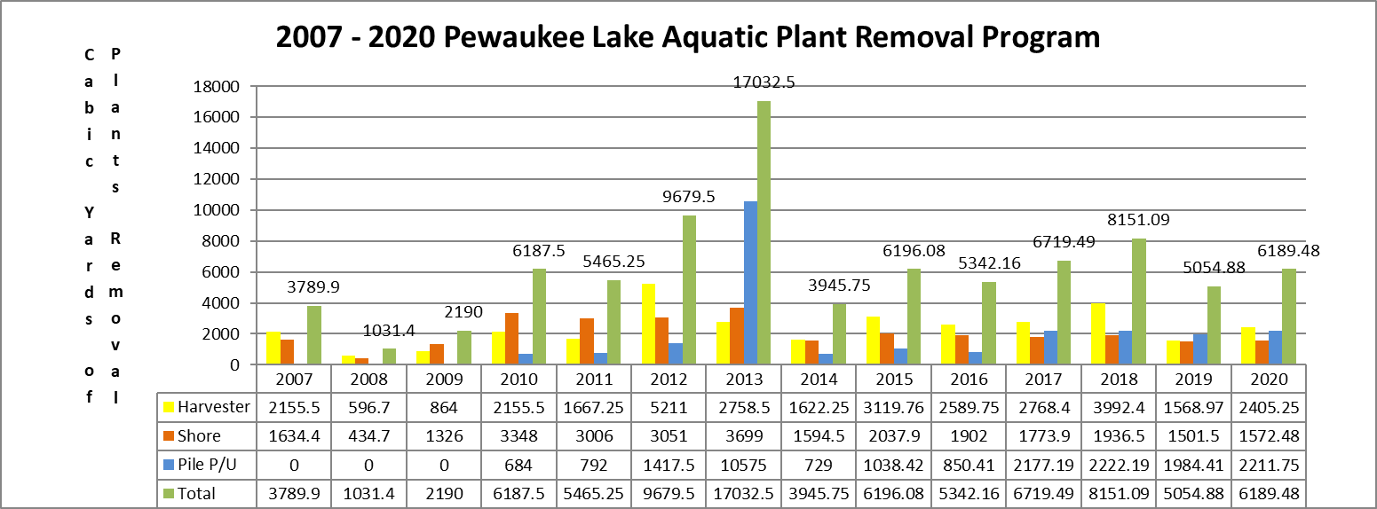

Over the last decade, we stepped up our Harvesting and aquatic plant removal program, implementing more equipment and more staff. The lake is constantly improving simply by the increased amount of nutrients we are removing from the lake with the harvesting program. Phosphorus is the main source of nutrients in the aquatic plants and in the lakes sediment. By removing large volumes of phosphorus we remove the nutrients that help the plants grow. We also remove the amount of decaying plants which use up oxygen to break down. Low oxygen is harmful to the fisheries and other aquatic life. So not only do we make the lake better for recreational use by harvesting and picking up plants we are also slowly improving the overall quality of the lake. This in turn improves home values in the Delafield and Pewaukee area.

Clean Streams = Clean Lake: The 3 main tributary’s to Pewaukee Lake are Coco, Meadowbrook and Zion Creeks. These provide most of the flow from the watershed and are extremely critical to the lake’s ecology, quality and clarity. Stream bank protection (native wetland vegetation, woody structure and rock) help minimize erosion. Stream buffers (75-100 foot wide strips of land bordering the streams) are absolutely critical for stream protection. Getting people to understand about buffers and streambank protection and spread the word is the answer in helping clean up the lake. To date the Lake Pewaukee Sanitary District has partnered with the local Pewaukee Chapter of Walleyes for Tomorrow and has helped install 300 feet of streambank restoration on Meadowbrook Creek. The restoration consists of coconut bio-logs and native prairie and wetland plantings. The bio-logs are heavily staked in place just inside of the eroded riverbanks. Native plants are planted in the bio-logs and behind the bio-logs. High flows overtopping the banks fill in the gaps behind the bio-logs with sediment and then the native plants spread out and flourish creating fish spawning areas and stream protection against erosion. This narrows the river and allows the river to flow faster providing cooler, deeper water which improves the natural spawning of fish and allows other aquatic life and organisms to flourish. The organisms eat algae which keeps the lake clean and clear. The District acquired a $50,000 WDNR matching grant to help with the financial aspects, but it takes other funds and volunteer time to make up the cost share of the grant. While achieving 300 feet of restoration is a great start, there are 1,000’s of feet that need attention. You want to clean a lake? Clean the streams and areas that drain into the lake. Get to the sources of the problem and that is just what these folks are doing. If you want to help, donations can be made to the “Lake Pewaukee Sanitary District Wetland Fund” and they are all tax deductible. If you want to volunteer and get your hands dirty call the District in Spring at 262-691-4485 and we will put volunteers to work. Thanks to all who have helped and donated in the past, we are making great progress!!

Employment – Summer Lake Crews
Lake Pewaukee Sanitary District will be looking to hire enthusiastic people to help with the lake operations this next year. The temporary summer employees work from early May until the end of August. The shift starts at 7:00 a.m. and ends at 3:30 p.m. with opportunities for overtime depending on lake conditions. Applications for the seasonal help will be accepted for review starting any time after January 1st, 2021. Applicants must be at least 18 years of age.
We also have a need for some temporary help that could start earlier and work through October. Call Rita at (262) 691-4485 for more information or go to our website at: www.lakepewaukee.org

